Ecommerce Sales Analysis

1. Project Overview -

This project analyzes Amazon sales data and compares product pricing across multiple platforms using Python, SQL, and Power BI to generate insights on sales performance and pricing strategies.

2. About Dataset -

The dataset used in this project consists of Amazon sales data and product pricing data collected from multiple e-commerce platforms such as Amazon, Flipkart, Myntra, and Ajio.

The Amazon sales dataset contains detailed information about orders, including order ID, date, product category, size, quantity, revenue, shipping details, and customer location (city and state).

The pricing dataset includes product-level information such as product ID (style_id), category, and price details across different platforms (Amazon, Flipkart, Myntra, and Ajio).

The data was preprocessed and cleaned using Python to handle missing values, remove unnecessary columns, and standardize formats. The cleaned datasets were then used for analysis and visualization.

Overall, the dataset enables comprehensive analysis of sales performance and cross-platform pricing comparison.

3. Exploratory data analysis using python -

Data cleaning -

The data cleaning process was performed using Python to ensure data quality and consistency before analysis.

First, missing values were identified and handled appropriately. Columns with a high number of missing values were either removed or filled with suitable replacements such as "Unknown" for categorical data and 0 for numerical fields.

Irrelevant and unnecessary columns such as 'fulfilled-by', 'promotion-ids', and unnamed columns were dropped to reduce noise in the dataset.

Column names were standardized by converting them into a consistent format (lowercase with underscores) for easier handling.

Data types were corrected by converting columns such as date into datetime format and numerical columns like amount and quantity into appropriate numeric types.

Duplicate records were identified and removed to maintain data integrity.

Additionally, values like "NULL" or "Nill" present as text were replaced with proper null values and handled accordingly.

After cleaning the dataset was structured and ready for analysis and visualization.
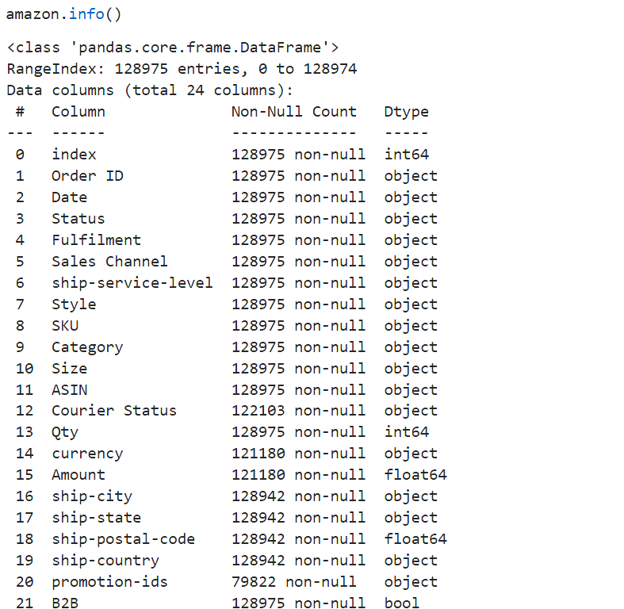

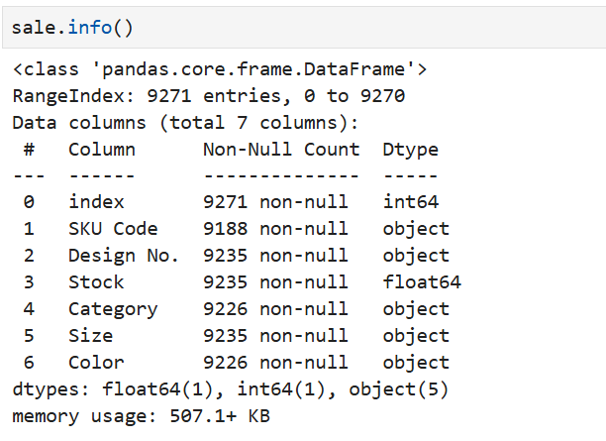

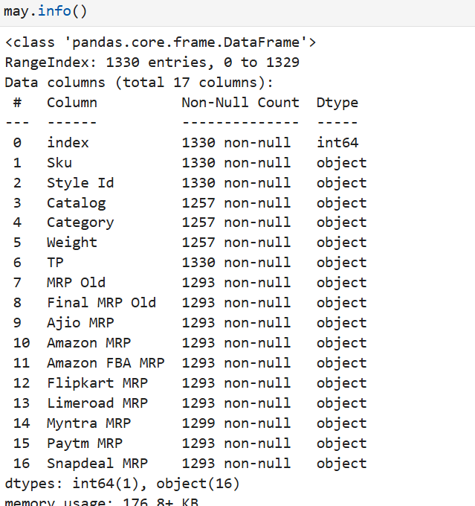

Data modeling -

Data modeling was performed after cleaning the datasets to prepare them for analysis.

The Amazon sales dataset and pricing dataset were structured separately and then partially integrated based on common product identifiers where applicable.

New features such as month and year were derived from the date column to enable time-based analysis.

Relevant columns were selected and unnecessary attributes were removed to create a streamlined dataset for analysis.

Data relationships were logically defined to support meaningful insights, such as linking product-level pricing with sales performance.

The final structured datasets were then exported and used for further analysis in SQL and visualization in Power BI.
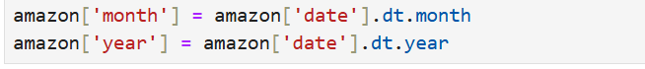

4. Data Analysis using sql

To gain meaningful business insights from the dataset, SQL queries were used to analyze sales performance, product trends, regional distribution, and pricing differences across platforms.

The following business questions were explored using SQL:

1.Highest Revenue by categories-To analyze and identify the product categories that contribute the highest revenue to overall sales.

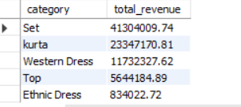

2.Overall sales revenue by states-To analyze and identify the states that contribute the most to overall sales revenue.

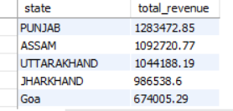

3. Top selling products based on revenue- To identify the top best-selling products based on revenue in order to understand high-performing items and customer demand.

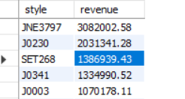

4. Monthly sales trend across the year - To analyze the monthly sales trend across the year to identify patterns and seasonality.

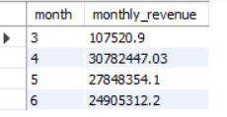

5. Distribution of order status- To analyze the distribution of order statuses (Delivered, Cancelled, etc.) to understand order fulfillment performance.

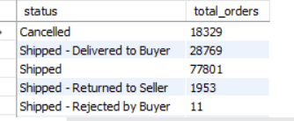

6. Average product revenue- To identify products that generate revenue above the average product revenue to highlight high-performing items.

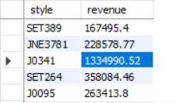
7.Top 5 states by revenue- To rank the top 5 states based on total revenue to identify the highest contributing regions.

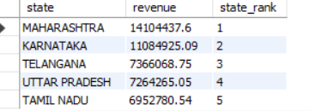

8. Average price of products across different platforms- To analyze the average price of products across different platforms to compare pricing strategies.

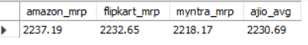

9. Highest price on amazon- To identify the products with the highest prices on Amazon to understand premium product positioning.

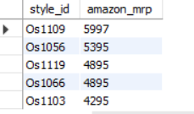

10. Lowest price for each product- To identify which platform offers the lowest price for each product to evaluate competitive pricing strategies.

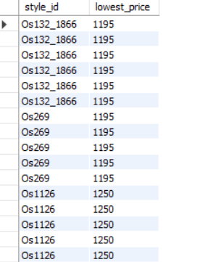

4. Dashboard in Power BI

The project includes two interactive dashboards developed using Power BI: the Amazon Sales Dashboard and the Pricing Analysis Dashboard.

The Amazon Sales Dashboard provides insights into overall sales performance, including total revenue, order volume, sales trends, category performance, and regional distribution. It helps in understanding customer demand, identifying top-performing products, and analyzing sales patterns over time.

The Pricing Analysis Dashboard focuses on comparing product prices across multiple platforms such as Amazon, Flipkart, Myntra, and Ajio. It highlights price differences, identifies the most competitive platform, and supports pricing strategy decisions.

Both dashboards include interactive filters that allow users to explore data dynamically based on categories, products, and locations.

Introduction -

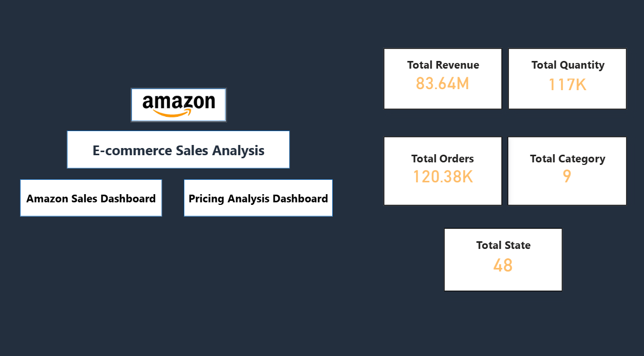

Amazon Sales Dashboard -

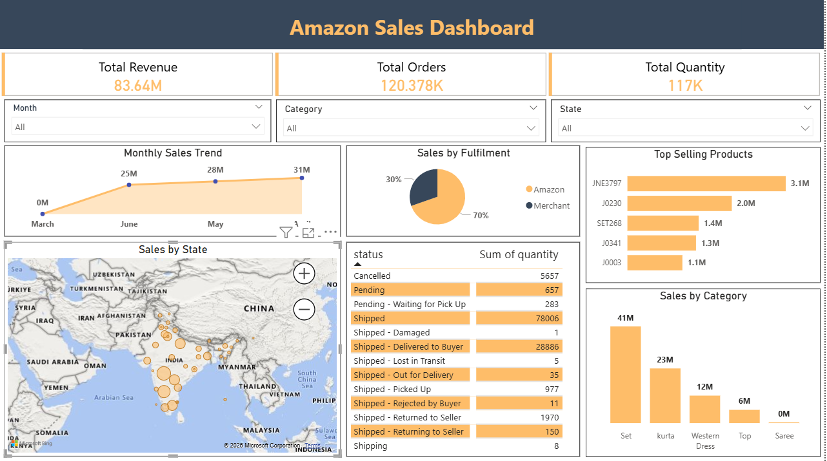

Pricing Analysis Dashboard -

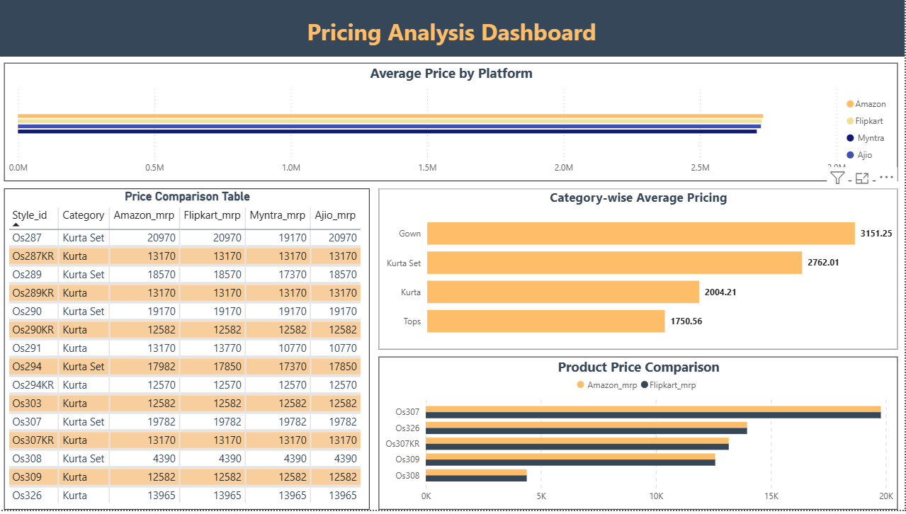

5. Conclusion -

This project successfully analyzes Amazon sales data and compares product pricing across multiple e-commerce platforms.

The analysis highlights key insights such as top-performing products and categories, monthly sales trends, and regional sales distribution. It also reveals significant price variations across platforms, helping to identify competitive pricing opportunities.

The dashboards provide a clear and interactive view of business performance, enabling better understanding of customer demand and sales patterns.

Overall, the project supports data-driven decision-making, helping businesses optimize pricing strategies, improve sales performance, and gain a competitive advantage in the e-commerce market.

6. Business Recommendations -

Based on the analysis, businesses should focus on top-performing categories and products to maximize revenue.

Pricing strategies should be optimized by monitoring competitor platforms and adjusting prices to remain competitive.

High-performing regions should be targeted with focused marketing strategies to increase sales.

Products with higher price differences across platforms should be reviewed to ensure competitive positioning.

Improving order fulfillment and reducing cancellations can enhance customer satisfaction and overall performance.

